IB Business Management: Finance Practice Test
Time: 60 Minutes
Total Marks: 30
Focus: AO1 (Knowledge) & AO4 (Calculation)

1. Alpine Adventures (AA)
Lauren owns Alpine Adventures (AA), a ski rental business. The business is seasonal.
On 1 November 2024, Lauren forecasted her cash flow for the upcoming peak season. She estimates the following for the first four months of operation:
- Opening Bank Balance (Dec 1): $1,500.
- Forecasted Sales Revenue:
  - December: $10,000
  - January: $20,000
  - February: $24,000
  - March: $12,000
- Inflow Terms: Lauren estimates that 60% of customers pay in cash in the month of sale. The remaining 40% are tour groups who pay on credit one month later. (e.g., 40% of December sales are received in January).
- Outflows:
  - Rent: $2,000 paid every month.
  - Wages: Calculated as 30% of the current month's sales revenue.
  - New Skis: A one-off purchase of $8,000 in December.
  - Electricity: $1,200 paid quarterly (paid in March only).
(a) State two features of trade credit. [2]
(b) Prepare a cash-flow forecast for AA for December 2024 through March 2025. [6]
(c) Comment on AA's liquidity position in December compared to March. [2]

2. GreenLeaf Furniture (GLF)
GreenLeaf Furniture (GLF) is switching from bespoke manufacturing to mass production of sustainable chairs. The Finance Director has provided a scrambled list of estimates for the year 2026 (see Table 1). He needs you to organize this into a usable financial statement.
Table 1: Unorganized financial estimates for GLF (2026)
Item | Value / Term
Rent for factory | $40,000 per year
Raw wood materials | $80 per chair
Marketing budget | 5% of total Sales Revenue
Selling price | $250 per chair
Electricity & Water (fixed) | $10,000 per year
Direct Labour | $50 per chair
Target Sales Volume | 2,000 chairs
Corporation Tax | 20% of Net Profit Before Tax
Interest payments | $5,000 per year
(a) Define the term revenue expenditure. [2]
(b) Using the information in Table 1:
(i) Construct a forecasted profit and loss account for GLF for 2026. [4]
(ii) Calculate the forecasted Profit Margin. [2]
(c) Explain one likely impact on GLF's gross profit margin if the cost of raw wood materials increases. [2]

3. SolarTech Innovations (STI)
SolarTech Innovations (STI), a private limited company, manufactures solar power solutions. The company is considering building a new photovoltaic panel factory to meet rising consumer demand.
The new factory will cost $15 million. The expected net cash flow from the facility is given in Table 4. The factory is expected to be sold after five years for a residual value of $3 million.
Table 4: Expected Net Cash Flow from STI’s new factory
Year | Net Cash Flow ($ million)
1 | 2
2 | 3
3 | 5
4 | 7
5 | 8
(a) Define the term loan capital. [2]
(b) For the new factory:
(i) Calculate the Payback Period (show all working). [2]
(ii) Calculate the Average Rate of Return (ARR) (show all working). [2]
(c) Comment on the usefulness of your answer from either b(i) or b(ii) for STI's investment decision. [2]

Markscheme

1. Alpine Adventures (AA)
(a) State two features of trade credit. [2]
Markscheme Features of trade credit include:
- Buy now, pay later / delayed payment terms (e.g., 30–60 days).
- It is a short-term source of finance.
- It is usually interest-free (if paid within the agreed period).
- It appears as Creditors (Accounts Payable) under Current Liabilities on the balance sheet.
- It improves the business's working capital / cash flow position (by keeping cash in the business longer).
- Risk of losing supplier goodwill or cash discounts if paid late.
Accept any other relevant feature. N.B. No description or application to the stimulus is required.
Award [1] for each relevant feature stated up to a maximum of [2].
(b) Prepare a cash-flow forecast for AA for December 2024 through March 2025. [6]
Markscheme
Cash flow forecast for Alpine Adventures (AA) December 2024 – March 2025
All figures in $ | Dec | Jan | Feb | Mar
Opening Balance | 1 500 | (5 500) | 2 500 | 15 700
Cash Inflows
Cash Sales (60%) | 6 000 | 12 000 | 14 400 | 7 200
Credit Sales (40%) | 0 | 4 000 | 8 000 | 9 600
Total Inflows | 6 000 | 16 000 | 22 400 | 16 800
Cash Outflows
Rent | 2 000 | 2 000 | 2 000 | 2 000
Wages (30%) | 3 000 | 6 000 | 7 200 | 3 600
New Skis | 8 000
Electricity |  |  |  | 1 200
Total Outflows | 13 000 | 8 000 | 9 200 | 6 800
Net Cash Flow | (7 000) | 8 000 | 13 200 | 10 000
Closing Balance | (5 500) | 2 500 | 15 700 | 25 700
Accept slightly different headings / format.
- Award [1] if the candidate conveys some understanding of what a cash flow forecast is, but otherwise the forecast is largely inaccurate, or incomplete.
- Award [2–3] if a cash flow forecast is drawn, but either it is not in a generally accepted format or it is untidy, and/or the forecast contains three or more errors (errors can be mathematical or formatting errors).
- Award [4–5] if the cash flow forecast is drawn essentially correctly and neatly in a generally accepted format, but there is one error for [5] or two errors for [4] (errors can be mathematical or formatting errors).
  - N.B. Allow candidate own figure rule (OFR): if a candidate makes an error in one row and carries it through the remainder of the forecast that is only one error.
- Award [6] if the cash flow forecast is drawn accurately and neatly in a generally accepted format and is error free.
(c) Comment on AA's liquidity position in December compared to March. [2]
Markscheme
December: The business has a liquidity problem / deficit (Closing balance of ($5 500)). This is due to high initial outflows (New Skis) and lower inflows.
March: The liquidity position has improved significantly (Closing balance of $25 700). The business is now solvent and has a healthy surplus.
- Award [1] for a basic comment describing the balances.
- Award [2] for a comment that compares the two positions using appropriate terminology (deficit/surplus, liquidity, solvent).

2. GreenLeaf Furniture (GLF)
(a) Define the term revenue expenditure. [2]
Markscheme Costs incurred on a day-to-day basis [1] for the ordinary running of a business/costs that do not lead to the creation of long-term assets (e.g., rent, wages, or raw materials) [1].
- Award [1] for partial understanding (e.g., "money spent on everyday things").
- Award [2] for a clear definition that includes both the day-to-day aspect and the exclusion of long-term asset creation.
(b)(i) Construct a forecasted profit and loss account for GLF for 2026. [4]
Markscheme
Forecasted Profit and Loss Account for GLF for the year ended 2026
 | Calculation | $
Sales Revenue |  | 500 000
Cost of Goods Sold | 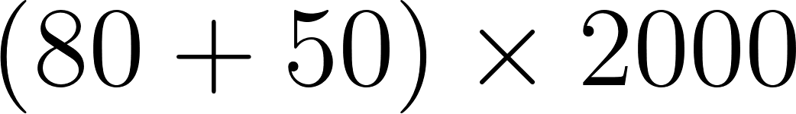 | (260 000)
Gross Profit |  | 240 000
Expenses
Rent |  | 40 000
Electricity & Water |  | 10 000
Marketing | 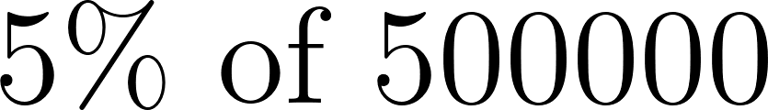 | 25 000
Total Expenses |  | (75 000)
Net Profit before Interest & Tax |  | 165 000
Interest |  | (5 000)
Net Profit before Tax |  | 160 000
Tax (20%) |  | (32 000)
Net Profit after Tax |  | 128 000
- Award [1] for correct format (Sales - COGS = GP...).
- Award [1] for correct calculation of Sales Revenue and COGS ($500,000 and $260,000).
- Award [1] for correct calculation of Expenses and Tax ($75,000 and $32,000).
- Award [4] for a completely correct P&L with all workings shown.
- Apply Own Figure Rule (OFR) throughout.
(b)(ii) Calculate the forecasted Profit Margin. [2]
Markscheme
Formula: 
Calculation: 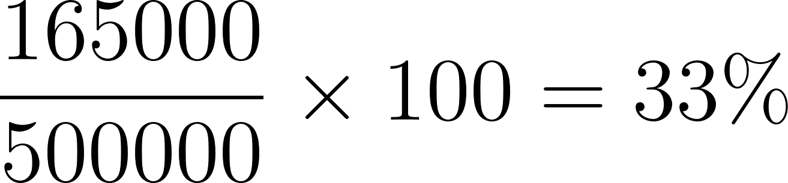
OR (using Net Profit Before Tax)
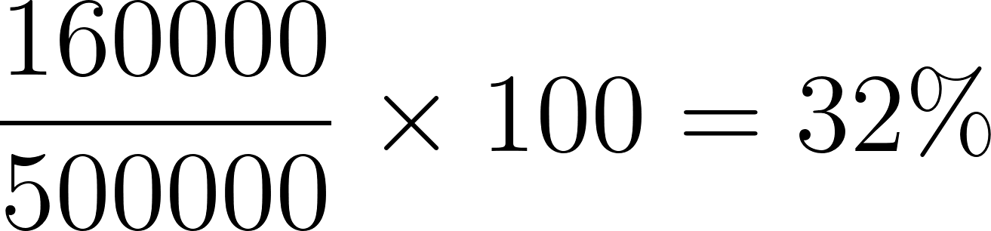
- Award [1] for correct working / formula.
- Award [2] for the correct answer.
- Allow OFR based on part (b)(i).
(c) Explain one likely impact on GLF's gross profit margin if the cost of raw wood materials increases. [2]
Markscheme
If the cost of raw wood materials increases, the Cost of Goods Sold (COGS) will increase [1]. Assuming the selling price remains the same, the Gross Profit will fall, leading to a lower Gross Profit Margin [1].

3. SolarTech Innovations (STI)
(a) Define the term loan capital. [2]
Markscheme
Funds sourced externally (debt finance) from financial institutions (e.g., banks) [1] that must be repaid (principal + interest) over an agreed period of time [1].
(b) For the new factory:
(i) Calculate the Payback Period (show all working). [2]
Markscheme
- Initial Cost: 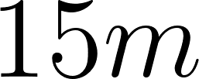.
- Cumulative Cash Flow: Y1 (2), Y2 (5), Y3 (10), Y4 (17).
- Amount left to recover after Year 3: .
- Cash Flow in Year 4: 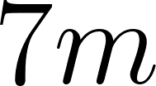.
- Calculation: 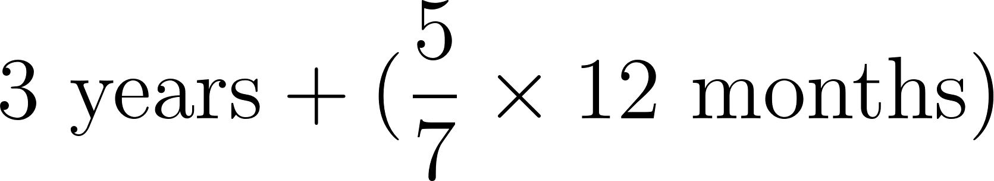
- (Accept 3.71 years)
Award [1] for correct working and [1] for the correct answer.
(ii) Calculate the Average Rate of Return (ARR) (show all working). [2]
Markscheme
- Total Net Cash Flow (Years 1–5): .
- Plus Residual Value: .
- Total Profit over Life: .
- Average Annual Profit: 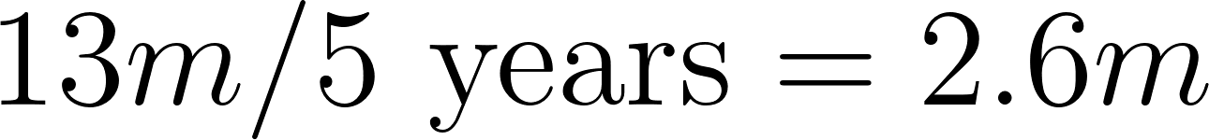.
- ARR: 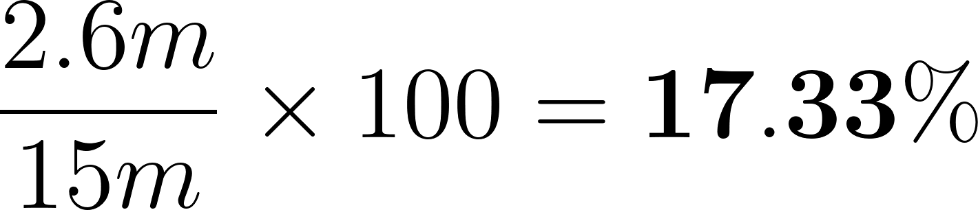
Award [1] for correct working / formula and [1] for the correct answer.
(c) Comment on the usefulness of your answer from either b(i) or b(ii) for STI's investment decision. [2]
Markscheme
Candidates may make any accurate commentary, as long as it reflects information from (b)(i) or (b)(ii).
- PBP: The payback of 3 years and 8.6 months is well within the 5-year project life [1]. This provides security, as STI will recover its capital quickly, reducing the risk associated with changes in solar energy demand [1].
- ARR: The ARR of 17.33% is a clear indicator of the project's profitability, allowing STI to compare it easily with prevailing bank interest rates or the returns of other projects [1]. However, it ignores the timing of the cash flows (Time Value of Money), which is a weakness [1].
Award [1] for a basic comment and an additional [1] for offering a reasoned explanation or evaluation.

